Creating a Step Functions API using Gateway

Step 1: Create an IAM Role for API Gateway

Select Roles

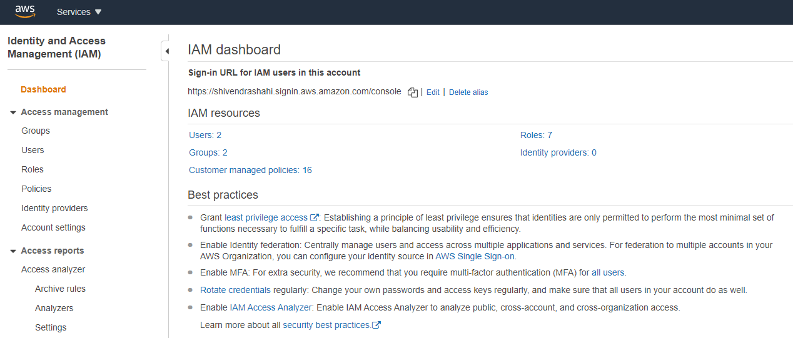

Create Role

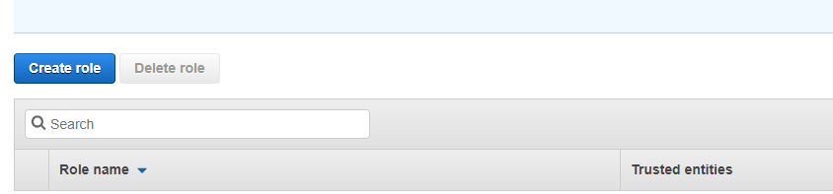

Select on type of trusted entity, AWS service, select API Gateway from the list. Choose Next: Permissions

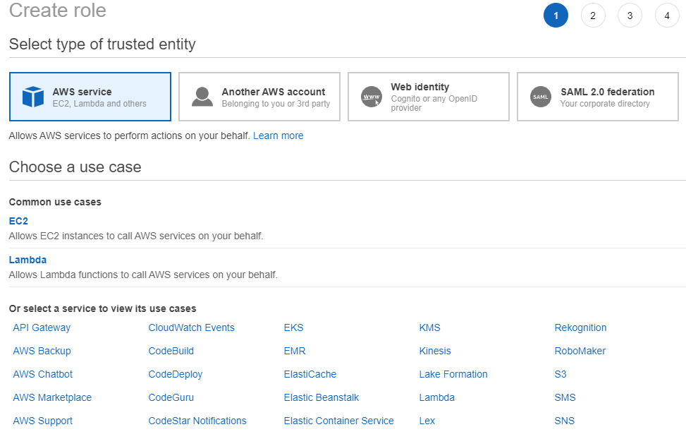

Select Next: Review

On the Review page, enter APIGatewayToStepFunctions for Role name, choose Create Role

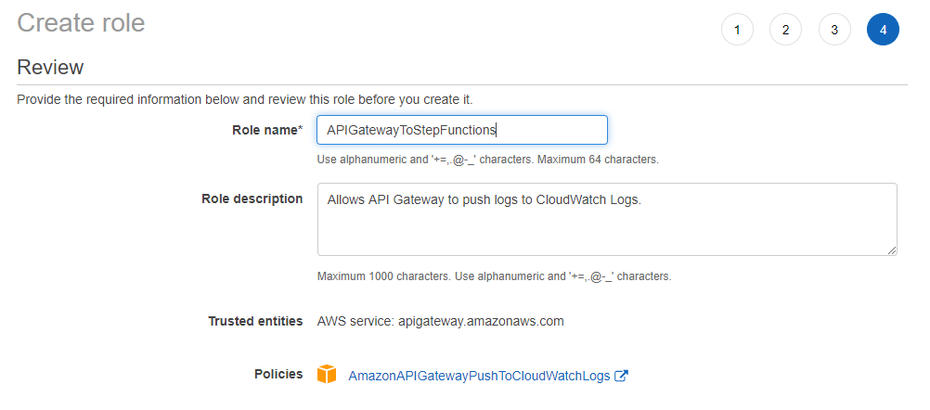

Note the Role ARN from the created Role



Attach a policy to the IAM role

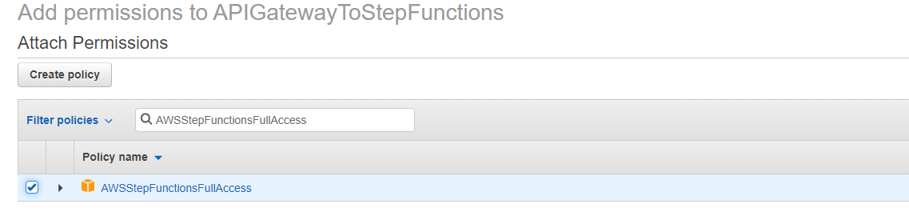

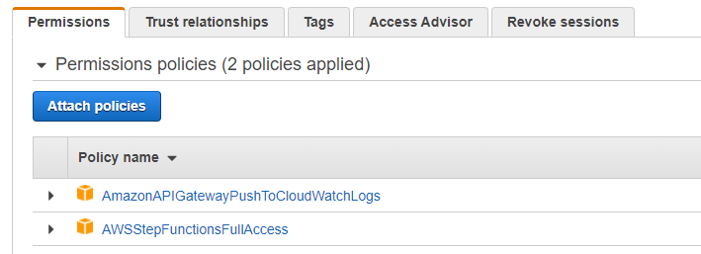

STEP 2 : Create your API Gateway API

Create the API

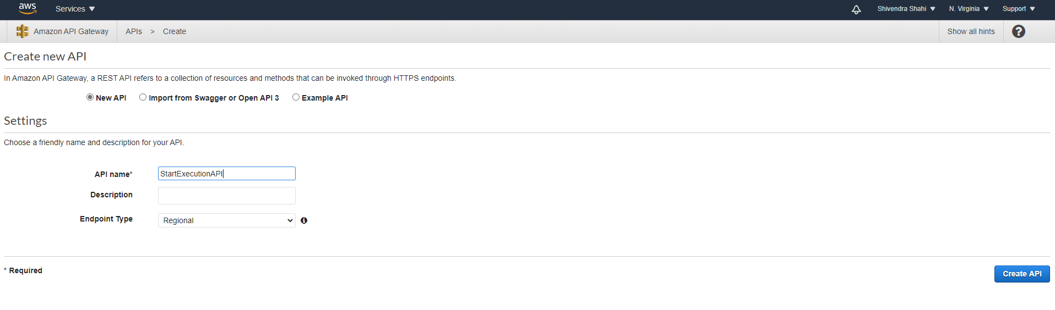

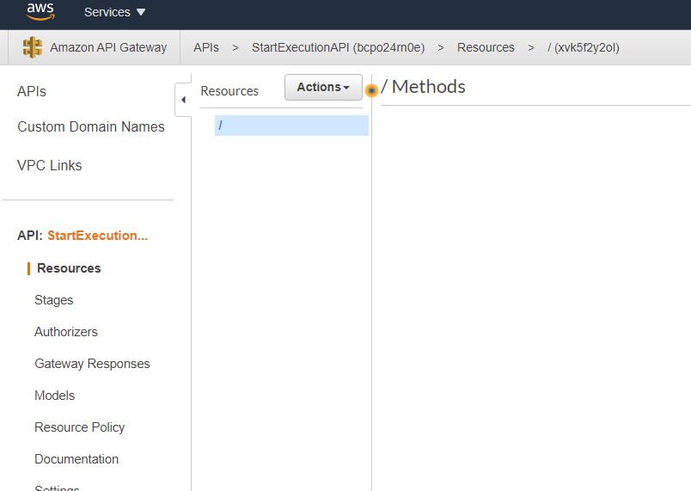

Create a Resource

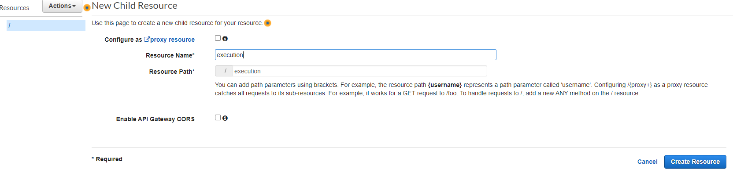

Create a POST method

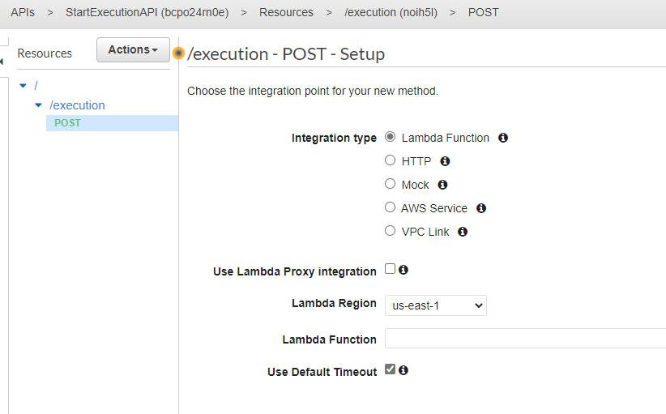

Integration type : AWS Service

AWS Region : us-east-1

HTTP Method : POST

Action Type : Use Action Name

Action : StartExecution

Execution Role : arn:aws:iam::898547467759:role/APIGatewayToStepFunctions

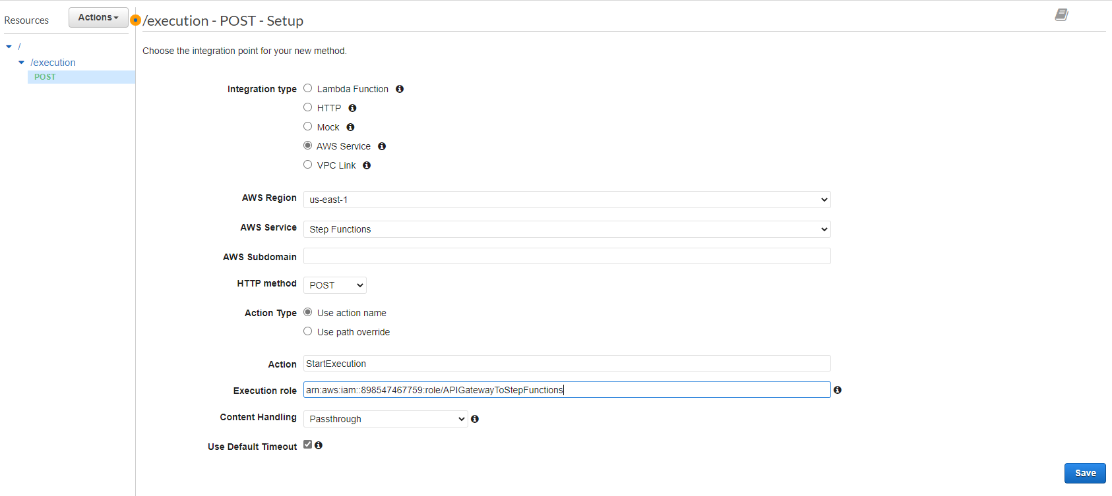

Save

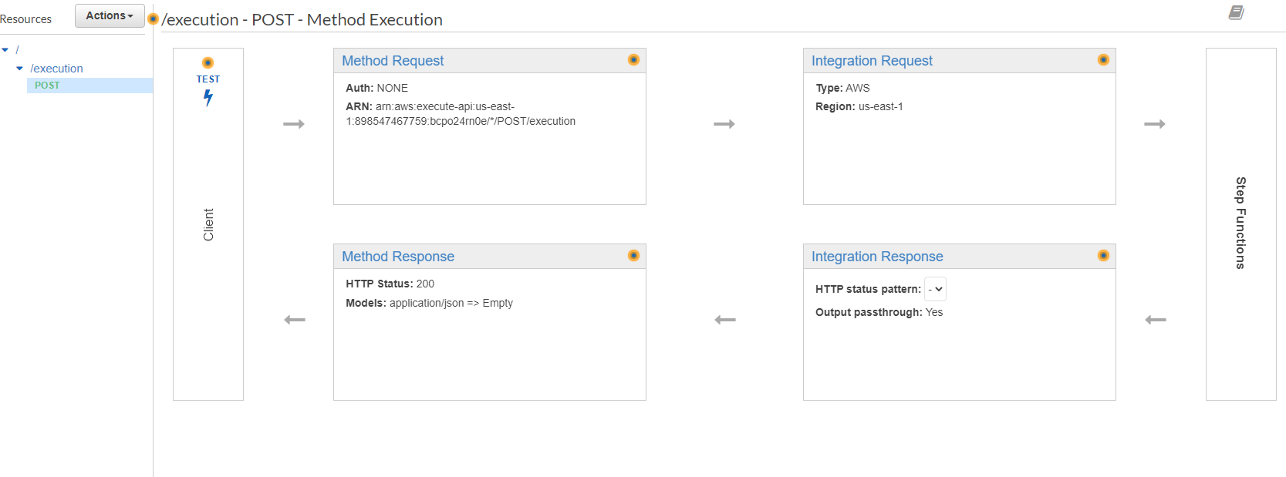

Test and Deploy the API Gateway

Test the Communication between API Gateway and Step Functions

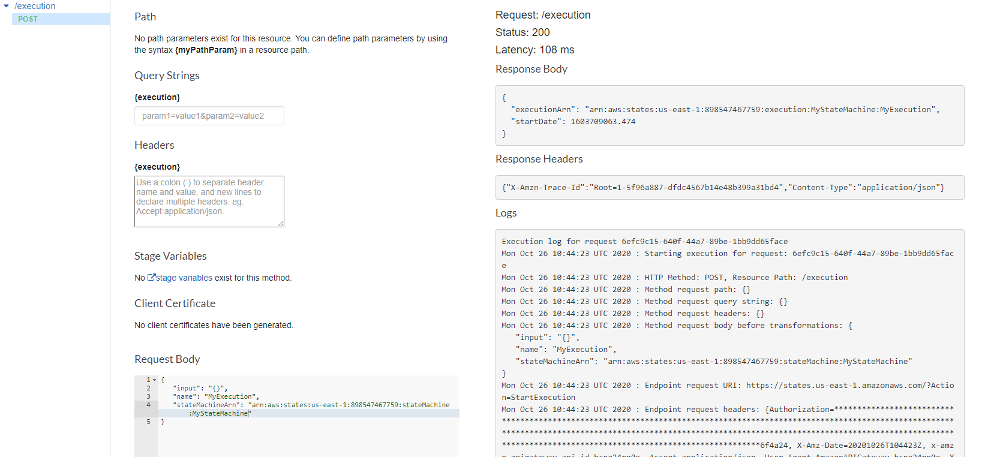

Deploy your API

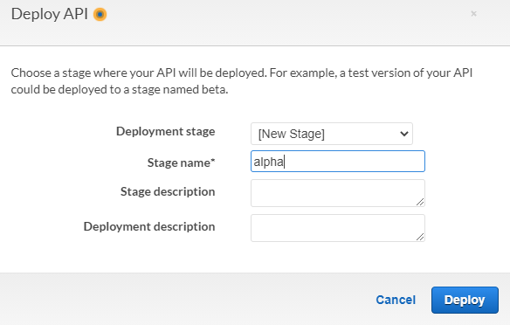

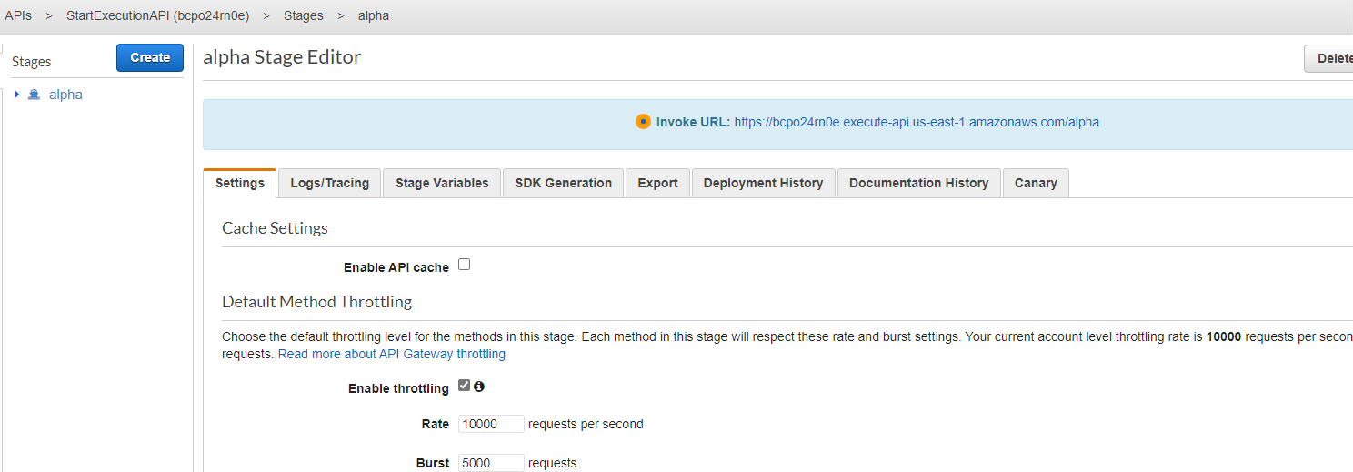

Test your Deployment

Invoke URL :

